Section 10.1: Graphing Quadratic Functions

SOLs: The student will
A.14

Objectives: Students will be able to:
- Graph quadratic functions
- Find the equation of the axis of symmetry and the coordinates of the vertex of a parabola

Vocabulary:
Quadrant –
Parabola –
Minimum –
Maximum –
Vertex –
Symmetry –
Axis of symmetry –

Key Concept:

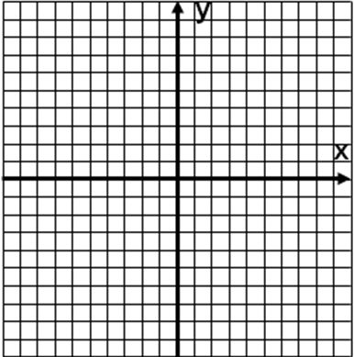
Examples:
- Use a table of values to graph y = x² – x – 2
- Use a table of values to graph y = -2x² + 2x + 4
- Consider the graph of y = -2x² – 8x – 2
A. Write the equation of the axis of symmetry.
B. Find the coordinates of the vertex.
C. Identify the vertex as a maximum or minimum.
D. Graph the function.
- Which is the graph of y = -x² – 2x – 2

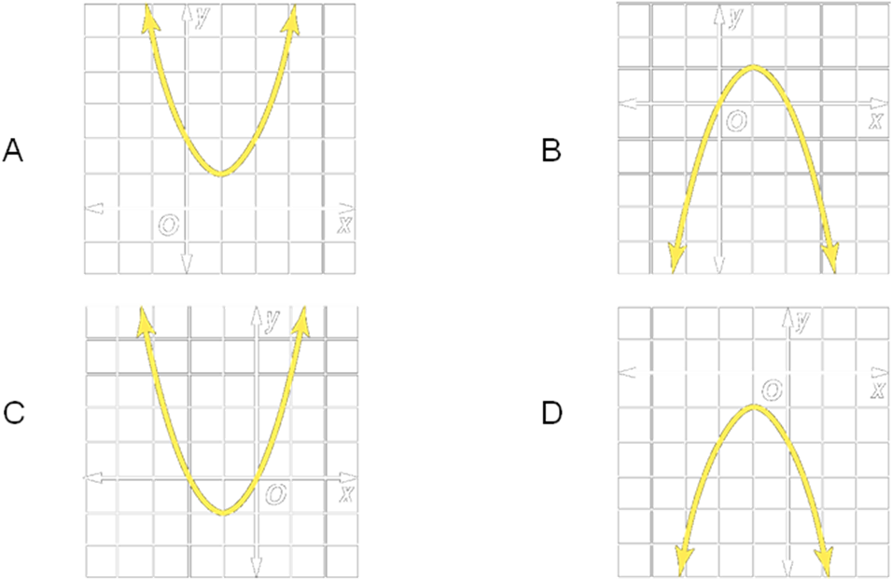

Concept Summary:
The standard form of a quadratic function is y = ax² + bx + c
Complete a table of values to graph a quadratic function
The equation of the axis of symmetry for the graph of y = ax² + bx + c, where a ≠ 0 is x = (-b/2a)
The vertex of a parabola is on the axis of symmetry

Homework: pg
Section 10.2: Solving Quadratic Equations by Graphing

SOLs: The student will
A.14

Objectives: Students will be able to:
Solve quadratic equations by graphing
Estimate solutions of quadratic equations by graphing

Vocabulary:
Quadratic equation –
Roots –
Zeros –

Key Concept:

Examples:
- Solve x² – 3x – 10 = 0
A. by graphing.
B. by factoring.
- Solve x² – 6x = -9
A. by graphing
B. by factoring
- Solve x² + 2x + 3 = 0 by graphing
- Solve x² – 4x + 2 = 0 by graphing. If integral roots cannot be found, estimate the roots by stating the consecutive integers between which the roots lie.
- Model Rockets: Shelly built a model rocket for her science project. The equation, y = -16t2 + 250t, models the flight of the rocket, launched from ground level at a velocity of 250 feet per second, where y is the height of the rocket in feet after t seconds. For how many seconds was Shelly’s rocket in the air?

Concept Summary:
The roots of a quadratic equation are the x-intercepts of the related quadratic function

Homework: pg
Section 10.3: Solving Quadratic Equations by Completing the Square

SOLs: The student will
A.14

Objectives: Students will be able to:
Solve quadratic equations by finding the square root
Solve quadratic equations by completing the square

Vocabulary:
Completing the square –

Key Concept:

Examples:
- Solve x² + 6x + 9 = 5 by taking the square root of each side. Round to the nearest tenth if necessary.
- Find the value of c that makes x² + 12x + c a perfect square.
- Solve x² – 18x + 5 = -12 by completing the square.
- Boating: Suppose the rate of flow of an 80-foot-wide river is given by the equation r = -0.01x² + 0.8x, where r is the rate in miles per hour, and x is the distance from the shore in feet. Joacquim does not want to paddle his canoe against a current faster than 5 miles per hour. At what distance from the river bank must he paddle in order to avoid a current of 5 miles per hour?

Concept Summary:
Complete the square to make a quadratic function a perfect square
Use the following steps to complete the square of x² + bx:
Step 1. Find ½ of b, the coefficient of x
Step 2. Square the result of step 1
Step 3. Add the result of step 2 to both sides of the equation

Homework: pg
Section 10.4: Solving Quadratic Equations by Using the Quadratic Formula

SOLs: The student will
A.14

Objectives: Students will be able to:
Solve quadratic equations by using the Quadratic formula
Use the discriminant to determine the number of solutions for a quadratic equation

Vocabulary:
Quadratic formula –
Discriminant –

Key Concept:

Examples:
- Use two methods to solve: x² – 2x – 35 = 0
A. Factoring:
B. Quadratic Formula:
- Solve 15x² – 8x = 4 by using the Quadratic Formula. Round to the nearest tenth if necessary.
- Space Travel: Two possible future destinations of astronauts are the planet Mars and a moon of the planet Jupiter, Europa. The gravitational acceleration on Mars is about 3.7 meters per second squared. On Europa, it is only 1.3 meters per second squared. Using the information and equation from Example 3 on page 548 in your textbook, find how much longer baseballs thrown on Mars and on Europa will stay above the ground than a similarly thrown baseball on Earth.
A. Mars:
B. Europa:
- State the value of the discriminant and then determine the number of real roots of the equation.
A. 4x² – 2x + 14 = 0
B. x² + 24x = -144
C. 3x² + 10x = 12

Concept Summary:
The solutions of a quadratic equation in the form ax² + bx + c = 0, where a ≠ 0, are given by
the Quadratic Formula,
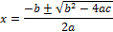
Homework: pg
Section 10.5: Exponential Functions

SOLs: none

Objectives: Students will be able to:
Graph exponential functions
Identify data that displays exponential behavior

Vocabulary:
Exponential function –

Key Concept:

Examples:
- Using y = 3^{x}
A. Graph it and state the y-intercept
B. Using the graph, estimate y when x = 1.5
- Using y = (¼)^{x}
A. Graph it and state the y-intercept
B. Using the graph, estimate y when x = -1.5
- Depreciation: People joke that the value of a new car decreases as soon as it is driven off the dealer’s lot. The function V = 25,000×0.82^{t} models the depreciation of the value of a new car that originally cost $25,000. V represents the value of the car and t represents the time in years from the time the car was purchased. Graph the function.
A. What values of V and t are meaningful in the function?
B. What is the value of the car after one year?
C. What is the value of the car after 5 years?
- Determine whether the sets of data displays exponential behavior
A.
B.
x | 0 | 10 | 20 | 30
y | 10 | 25 | 40 | 55
x | 0 | 10 | 20 | 30
y | 10 | 25 | 62.5 | 156.25

Concept Summary:
An exponential function is a function that can be described by the equation of the form y = a^{x}, where a > 0 and a ≠ 1

Homework: pg
Section 10.6: Growth and Decay

SOLs: The student will
A.3

Objectives: Students will be able to:
Solve problems involving exponential growth
Solve problems involving exponential decay

Vocabulary:
Exponential growth –
Exponential decay –
Compound interest –

Key Concept:

Examples:

- Population: In 2000, the United States had a population of about 280 million, and a growth rate of about 0.85% per year.
A. Write an equation to represent the population of the United States since the year 2000.
B. According to the equation, what will be the population of the United States in the year 2010?
- Compound Interest: When Jing May was born, her grandparents invested $1000 in a fixed rate savings account at a rate of 7% compounded annually. The money will go to Jing May when she turns 18 to help with her college expenses. What amount of money will Jing May receive from the investment?
- Charity: During an economic recession, a charitable organization found that its donations dropped by 1.1% per year. Before the recession, its donations were $390,000.
A. Write an equation to represent the charity’s donations since the beginning of the recession.
B. Estimate the amount of the donations 5 years after the start of the recession.
- Depreciation: Jackson and Elizabeth bought a house when they first married ten years ago. Since that time the value of the real estate in their neighborhood has declined 3% per year. If they initially paid $179,000 for their house, what is its value today?

Concept Summary:
Exponential Growth: y = C(1 + r)^{t}, where y represents the final amount, C represents the initial amount, r represents the rate of growth expressed as a decimal and t represents time.
Exponential Decay: y = C(1 – r)^{t}, where y represents the final amount, C represents the initial amount, r represents the rate of decay expressed as a decimal and t represents time.
Compound Interest: A = P(1 + r/n)^{nt}, where A represents the amount of the investment, P represents the amount of the principal, n represents the number of times interest is compounded each year, r represents the rate of change of interest expressed as a decimal and t represents the number of years of the investment.

Homework: pg
Section 10.7: Geometric Sequences

SOLs: The student will
A.5

Objectives: Students will be able to:
Recognize and extend geometric sequences
Find geometric means

Vocabulary:
Geometric sequence –
Common ratio –
Geometric means –

Key Concept:

Examples:
- Determine whether the sequence is geometric.
A. 1, 4, 16, 64, 256, …
B. 1, 3, 5, 7, 9, 11, …
- Find the next three terms in the geometric sequence.
A. 20, –28, 39.2, …
B. 64, 48, 36, …
- Geography: The population of the African country of Liberia was about 2,900,000 in 1999. If the population grows at a rate of about 5% per year, what will the population be in the years 2003, 2004, and 2005?
- Find the eighth term of a geometric sequence in which a₁ = 7 and r = 3
- Find the geometric mean in the sequence 7, ___, 112.

Concept Summary:
A geometric sequence is a sequence in which each term after the nonzero first term is found by multiplying the previous term by a constant called the common ratio r, where r ≠ 0 or 1
The nth term an of a geometric sequence with the first term a₁ and a common ratio r is given by a_{n} = a₁r ^{n-1}

Homework: pg

